Data Structures for Disjoint Sets

Application: Connected Components Minimum Spanning Tree

Disjoint Sets
l Some applications require maintaining a collection of disjoint sets.

l
l A Disjoint Set S is a collection of sets

S₁, Sn

∀i≠j Si
where
∩ S j =φ

l Each set has a representative which is a member of the set (usually the minimum if the elements are comparable)

l Make-Set(x) – Creates a new set Sx where x is it’s only element (and therefore it is the representative of the set).
O(1) time.

l
l Union(x, y) – Replaces

Sx , Sy by

Sx ∪ Sy .

One of the elements oSf_{x}
- Sy
becomes the

representative of the new set.
O(log n) time.
l

l Find(x) – Returns the representative of the set containing x
O(log n) time.

l We usually analyze a sequence of m operations, of which n of them are Make_Set operations, and m is the total of Make_Set, Find, and Union operations.
l
l Each union operations decreases the number of sets in the data structure, so there can not be more than n-1 Union operations.
l

Applications

l Equivalence Relations (e.g Connected Components)
l

l Minimum Spanning Trees

l Given a graph G we first preprocess G to maintain a set of connected components
CONNECTED_COMPONENTS(G)

l Later a series of queries can be executed to check if two vertexes are part of the same connected component
SAME_COMPONENT(u, v)

CONNECTED_COMPONENTS(G)
for each vertex v in V[G] do MAKE_SET (v)
for each edge (u, v) in E[G] do
if FIND_SET(u) != FIND_SET(v) then UNION(u, v)

SAME_COMPONENT(u, v)
if FIND_SET(u) == FIND_SET(v) then return TRUE
else return FALSE

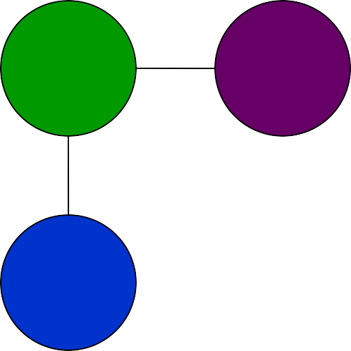
e
f
g
h
i
j
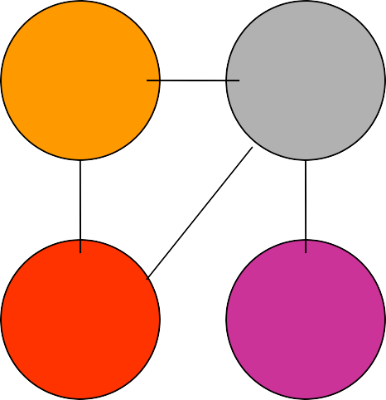
a
b
c
d

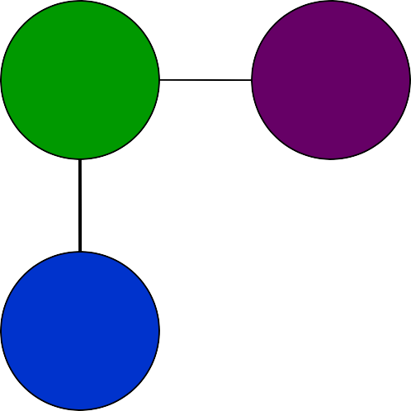
e
f
g
h
i
j
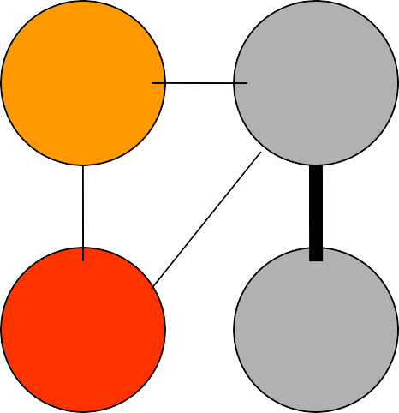
a
b
c
d

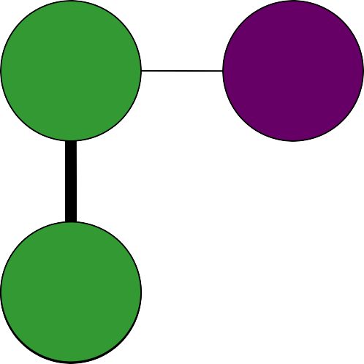
e
f
g
h
i
j
a
b
c
d

e
f
g
h
i
j
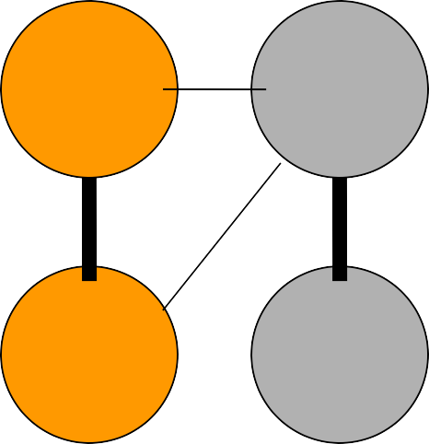
a
b
c
d

e
f
g
h
i
j
a
b
c
d

e
f
g
h
i
j
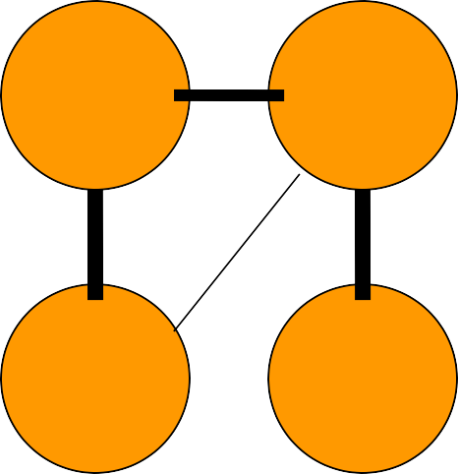
a
b
c
d

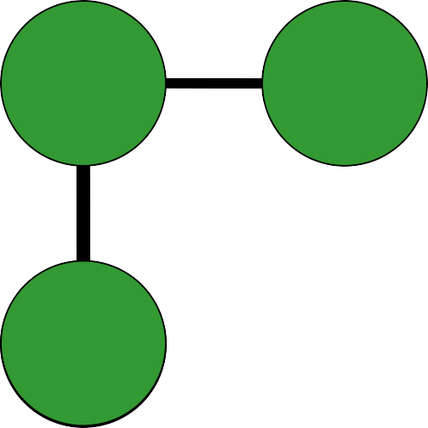
e
f
g
h
i
j
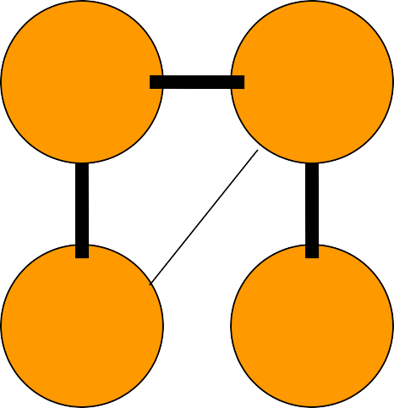
a
b
c
d

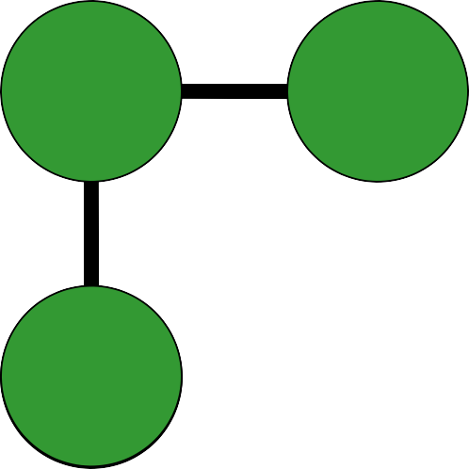
e
f
g
h
i
j
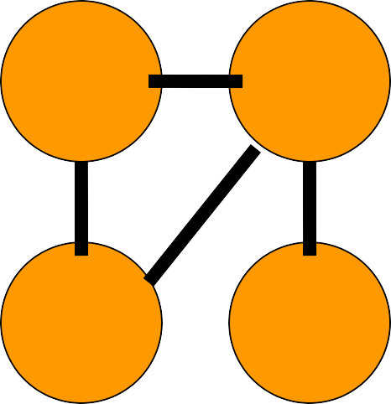
a
b
c
d

e
f
g
h
i
j
a
b
c
d

l During the execution of CONNECTED-COMPONENTS on a undirected graph G = (V, E) with k connected components, how many time is FIND-SET called?
How many times is UNION called? Express your answers in terms of |V|, |E|, and k.

l FIND-SET is called 2|E| times.
n FIND-SET is called twice on Line 4, which is executed once for each edge in E[G].

l
l UNION is called |V| - k times.
n Lines 1 and 2 create |V| disjoint sets.
n Each UNION operation decreases the number of disjoint sets by one. At the end there are k disjoint sets, so UNION is called |V| - k times.
Disjoint-Set Implementation: Linked List

l We maintain a set of linked list, each list corresponds to a single set.
l
l All elements of the set point to the first element which is the representative
l
l A pointer to the tail is maintained so elements are inserted at the end of the list

Set {c, h, e}

Set {f, g}

UNION of
e
h
c
g
f
two Sets
head
tail

head tail

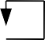
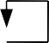
c
h
e
head tail
f
g

l A simple implementation: UNION(x, y) just appends x’s list to the end of y’s list, updates all back-to-representative pointers in x’s list to the head of y’s list.
l Each UNION takes time linear in the x’s length.
l Suppose n MAKE-SET(xi) operations (O(1) each) followed by
n-1 UNION
n UNION(x₁, x₂), O(1),
n UNION(x₂, x₃), O(2),
n …..
n UNION(xn-1, xn), O(n-1)
l The UNIONs cost 1+2+…+n-1=Θ(n2)
l So 2n-1 operations cost Θ(n2), average Θ(n) each.
l Not good!! How to solve it ???

l Instead appending x to y, append the shorter list to the longer list.
l Associated a length with each list, which indicates how many elements are in the list.
l Result: a sequence of m MAKE-SET, UNION, FIND-SET operations, n of which are MAKE-SET operations.
The running time is O(m + n log n). Why???

Hints: Count the number of updates to back-to-representative pointer for any x in a set of n elements. Consider that each time, the UNION will at least double the length of united set, it will take at most log n UNIONS to unite n elements. So each x’s back-to-representative pointer can be updated at most log n times.

l Rooted trees, each tree is a set, root is the representative.
Each node points to its parent. Root points to itself.

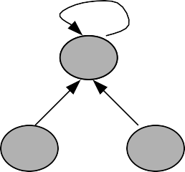
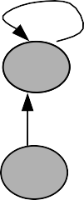
c
h
e
cf d

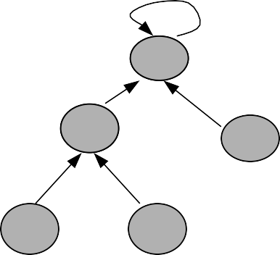
Set {c, h, e} Set {f, d}
cf
c
d
h
e

UNION

l Three operations
n MAKE-SET(x): create a tree containing x. O(1)
n FIND-SET(x): follow the chain of parent pointers until to the root. O(h), h is height of x’s tree
n UNION(x, y): let the root of one tree point to the root of the other. O(1)

n
l It is possible that n-1 UNIONs results in a tree of height
n-1. (just a linear chain of n nodes).

l
l So n FIND-SET operations will cost O(n2).
Union by Rank & Path Compression Heuristics

l Union by Rank: Each node is associated with a rank, which is the upper bound on the height of the node (i.e., the height of subtree rooted at the node), then when UNION, let the root with smaller rank point to the root with larger rank.
l
l Path Compression: used in FIND-SET(x) operation, make each node in the path from x to the root directly point to the root. Thus reduce the tree height.
Path Compression

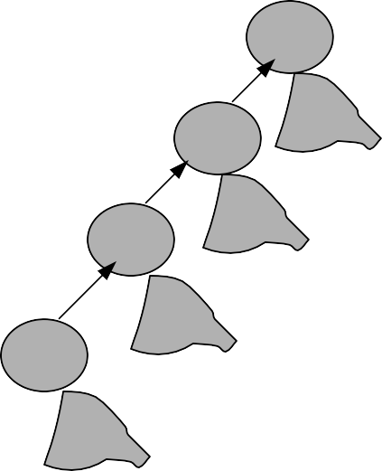
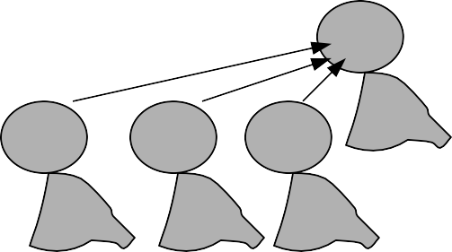
f
e
d
c
f
c
d
e

Path compression can cause a very deep tree to become very shallow
Algorithm for Disjoint-Set Forest
UNION(x, y)
1. LINK(FIND-SET(x), FIND-SET(y))

  - Worst case running time for m MAKE-SET, UNION, FIND-SET operations is: O(m⋅ α(n)), where α(n) ≤ 4. So nearly linear in
LINK(x, y)
1.
2.
3.
4.
5.
if rank[x] > rank[y]
then p[y] ←x
else p[x] ←y
if rank[x] = rank[y]
then rank[y]++
FIND-SET(x)
1.
2.
3.
if x≠ p[x]
then p[x] ←FIND-SET(p[x])
return p[x]

MAKE-SET(x)
- p[x]←x
- rank[x]←0
m.
•
  - The find operation does not change: O(log n)

l Describe a data structure that supports the following operations:
l
n find(x) – returns the representative of x
n union(x, y) – unifies the groups of x and y
n min(x) – returns the minimal element in the group of x

l We modify the disjoint set data structure so that we keep a reference to the minimal element in the group representative.
l
l The find operation does not change (log(n))
l
l The union operation is similar to the original union operation, and the minimal element is the smallest between the minimal of the two groups
l

l Executing find(5)
7 ◊1◊ 4◊ 4
1
Parent 4 min
2
7
3
4
4
4
1
5
7
6
6
6
..N
4
6
3
1
7
2
5

l Executing union(4,6)

1
Parent 4 min
2
7
3
4
4
4
1
5
7
6
4
1
..N
4
6
3
1
7
2
5

